EV3 Data Logging Assessment
- How do you command the robot to start or stop logging data as part of a program?
- What step should you take before starting or stopping data logging?

- Which sensors are we measuring in the block below?

- In the block below, how often will a samples be taken?

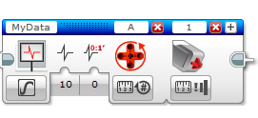

- How do you find out what each sensor reading is at specific time in the sensor reading?

